NAB accessbility action plan
2023 - 2024
disability inclusion and accessibility

Contents
Our Vision for Disability Inclusion and Accessibility 3
Supporting our vision 3
Valuable 500 3
Purple Space 3
AND CEO Message 3
What we’ve achieved 4
Dashboard 5
PACE Mentoring 5
Benchmarking our progress 5
Stepping Into internship program 5
Designing Accessible and Inclusive workplaces 5
Inclusion through employment – Our with Job Support 6
Our employee resource group NABility 8
Meet our new NABility Chairs 8
Our Accessibility Action Plan 2023-2024 10
Our Governance and Leadership 10
Your feedback helps 11
Alternative Access Formats 11

Welcome message by our Executive Sponsor
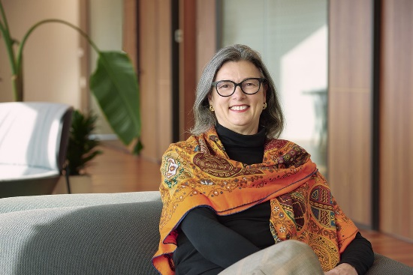

At NAB, we’re committed to inclusion and accessibility for everyone, including our customers, colleagues and community with disability. I’m proud of the work we’ve done so far in this space, as we continue to embed greater accessibility across our business.

The 2021-2022 Accessibility Action Plan kickstarted many exciting projects for NAB. One of these is connecting with disability organisations through our Accessibility Roundtables, so that we can gain insight into what good looks like, directly from people with disability. They’ve been a huge success.

Our focus in 2022 was to better understand the customer experience in banking, as well as best practice approaches for the employment and retention of people with disability. These learnings are informing how we act and what we do with the goals and actions in this, and future, Accessibility Action Plans.

Our partnerships with disability organisations have opened up further innovative opportunities for NAB. This includes the development of sensory maps for our commercial buildings, and more effective ways to use our expertise through NAB Neighbourhood volunteering.

We’ve created the Inclusive Banking Guidance Tool for Product Managers to support product teams to reach their accessibility goals. Also, our research processes include testing and input by people with disability. This is to ensure the development of our products and services are more accessible and inclusive. Our benchmarking score has improved significantly too.

Our Access and Inclusion Index submission scoring is 71/100, which is up from the 47/100 we scored 2 years earlier.

I’m pleased to share our Accessibility Action Plan 2023 – 2024. It outlines our commitment to innovation, disability inclusion and accessibility across the entire business. I look forward to updating you again soon with our progress.

Sharon Cook Group Executive, Legal Commercial Services

Our Vision for Disability Inclusion and Accessibility

At NAB, we welcome all people with disability. We recognise their skill, expertise and contribution, as customers, colleagues and valued members of the community. Our Accessibility Action Plan is our roadmap to help us get there. One of our goals is to be an employer of choice for people with disability. We want people to feel and know they belong as a valued team member. That they are empowered to bring their whole selves to work and are recognised for the value and contribution they bring to our business every day.

The plan is also strengthening our inclusive culture. Helping us address unconscious bias, as well as the soft bigotry of low expectations for people with disability. With 4.4 million Australians reporting they have disability, inclusion and accessibility is essential for our customers. Creating an inclusive and accessible banking experience for customers matters to us in how we act and what we do.

Supporting our vision
We’re not alone in this vision. We’re supported in this vision through our membership with the Valuable 500, the Australian Network on Disability (AND) and Purple Space. It’s with their measurement tools, programs, insight and information that we’re able create a more inclusive workplace and banking experience.

Valuable 500
We’re proud to be members of the Valuable 500. A global business collective made up of 500 CEOs and their companies innovating together for disability inclusion. Through this membership, our CEO Ross McEwen has committed to embedding disability inclusion across leadership, culture and brand experience. We’re also participating in the Valuable 500 ‘Generation Valuable’ mentoring program for 2023 by holding collaboration sessions with other global members and taking part in their global annual Valuable Truth survey.

Purple Space
We are also members of PurpleSpace. The world’s only professional development and leadership hub for disability Employee Resource Group (ERG) network leaders, allies and senior champions. “We improve business performance by helping organisations learn from their employees with disabilities. We call it ‘building disability confidence from the inside out’. It’s generated a global movement for positive cultural change.” – PurpleSpace

AND CEO Message

Congratulations to NAB on the launch of your new Accessibility Action Plan 2023-2024. By regularly developing and publicly sharing accessibility plans, NAB demonstrates its ongoing commitment to advancing the inclusion of people with disability as employees, customers and in the Australian community

The new plan sets out exciting objectives for the next two years and demonstrates a focus on continuous improvement and growth. The collaborative approach to build this plan ensures people with lived experience have been included in its key decisions and strategies.

However, the many achievements over the last two years should not be overlooked. Including the work in partnership with AND. Such as regular participation in AND’s Positive Action Towards Career Engagement (PACE) and Stepping Into Programs (SIP). As well as ongoing submissions for the annual Access and Inclusion Index.

Australian Network on Disability are proud to have been partnering with NAB since 2011 on a range of initiatives and projects. We look forward to continuing to support NAB to create a more equitable and inclusive Australia. Corene Strauss CEO, Australian Network on Disability

Corene Strauss
CEO, Australian Network on Disability
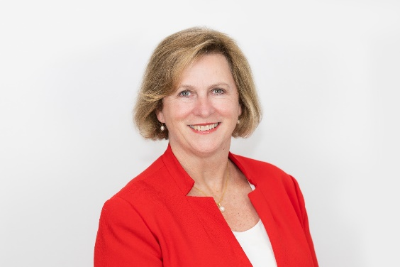

What we’ve achieved
At NAB, we want to be as good with people as we are with money. Of course, this extends to how we support and communicate with people with disability. Recently, we’ve enhanced the customer experience to be even more accessible and inclusive. Here are some highlights.

Feedback made easier
Our communication and feedback channels are now more accessible. Our Complaints Policy has more options for customers with disability to share feedback and make complaints in a way that works for them

Roundtable collaboration
Last year we held two Accessibility Roundtables, bringing disability organisations together to discuss customer experience and the employment and retention of people with disability. These sessions help us better serve customers with disability and keep talented people with disability as NAB colleagues. We’ll continue holding roundtables as part of this Accessibility Action Plan.

Setting a new standard
We’ve established our own Standard for Accessibility across all areas of NAB. We can support our colleagues to include accessibility in digital, products and services, communication and marketing, building design and how we serve customers.

Working together
To make sure we’re getting it right, our products and service teams include input and testing from people with disability from start to finish.
Towards accreditation
We’re embedding accessibility across our employee lifecycle. We are reviewing and improving our career development process for people with disability and teaming up with AND to become accredited Disability Confident Recruiters.

Partnering up
We’ve continued to work alongside disability organisations to solve emerging issues impacting their communities. We’re also refining our plan to make sure there are even more volunteering opportunities for our people to get involved.

Dashboard

PACE Mentoring
We’ve been involved in the PACE mentoring program since 2020, run by AND. So far, we’ve had over 50 mentors help boost the confidence of jobseekers with disability. In Autumn 2022, all our mentees that applied for jobs were successful in their applications.
“I loved this program and found it extremely valuable in developing my own disability confidence.”

Benchmarking our progress
Every two years, we make a submission to the Access and Inclusion Index. Since our submission in 2020, we’ve seen a significant increase in our score and we’ll keep incorporating the Index’s recommendations into our work for improved accessibility.

Stepping Into internship program
Through the Stepping Into internship program, we offer university students with disability the exciting opportunity to work their summer breaks with us. Giving them valuable experience in a large corporate environment and setting them up for future success after they graduate.

Designing Accessible and Inclusive workplaces
Accessibility and Inclusion is about people and considering all the needs of everyone we serve. An integral part of this thinking includes the way we approach the design and build of our workplaces.

Our Group Property team are ensuring that our commercial buildings are more accessible and inclusive for our colleagues with visible and invisible disability, from design to development.

To keep the team progressing, they’ve consulted with our employee resource group, NABility, to seek ongoing feedback for improvement. Through this process, they’ve developed the Design for Dignity Beyond Compliance guidelines.

Our Property Services team have consulted with NABility and Amaze to develop sensory maps. These help our colleagues better navigate our workplaces and choose the spaces that best support how and where they want to work.

Inclusion through employment – Our with Job Support
Our Executive General Manager for Global Markets. He attended a conference where Jobsupport (Australia’s leading employment service for people with moderate intellectual disability) were presenting. It inspired him to bring more people with disability into the Markets team.

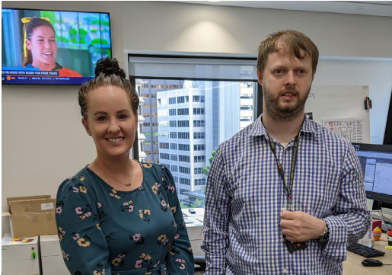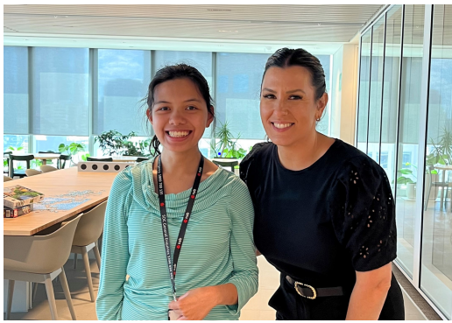
We now team up with Jobsupport. A partnership that’s resulted in us bringing on talented and passionate people, who’ve found belonging and independence at NAB. It’s also brought significant value to our team. Here are just a couple of stories.

How Alistair creates a safer workplace
Alistair’s been working at NAB for seven years, assisted by Jobsupport. With Emma as his People Leader, he works in the Dealing Room support team. Their role is to support the trading floors across Australia with staff movements, projects, events, security management and admin tasks.

For Emma, Alistair’s an integral part of the team. He not only brings his skills and passion to the table, but also supports the wider team’s understanding of why inclusion is important. Demonstrating the value that people with disability bring to the workplace and how to create a more supportive and inclusive environment.

For Alistair, he feels his role has given him independence, confidence and a strong sense of belonging. “I love contributing to issues across the floor and making it a safer working environment.” Alistair

How CJ makes admin a breeze
Like Alistair, CJ works in the Dealing Room support team in Melbourne. CJ never fails to bring a smile and can-do attitude to work every day, and is always keen to learn new tasks and skills. For Bonnie and Anthea, CJ is a valued member of the Markets team and an absolute delight to work with.

“CJ has helped Bonnie and I tremendously with our admin tasks, as well as ensuring our office space is tidy and supplies are always replenished accordingly.” Anthea

“I like working at NAB because I like meeting new people and working with Bonnie and Anthea.” CJ

Making digital experiences more equitable.

At NAB, we aim to create digital experiences that always look, feel and behave the same way for everyone. Getting there is an exciting and important challenge and one that needs a team effort.

Enter NAB’s Nuitathon
Our digital team uses a NAB User Interface Toolkit. It’s a library with all the different parts we need to build new websites and digital experiences. We call it NUIT for short.

In August 2022, after months of preparation, our Digital Accessibility team ran NAB’s first ever Nuitathon, led by Simone Wisniewski. The primary goal of the event was to find ways to improve the accessibility of the NUIT library features.

It was launched by Lance Thornswood (Executive Chief Design Officer) and Damian Fitzgibbon (Exec Tech Digital Enterprise Platforms). With Angie Mentis (Chief Digital, Data & Analytics Officer) declaring the winning team.

How it worked
One day. 10 teams. 140 participants. 76 tasks. All geared towards finding innovative solutions to greater NUIT accessibility.

During the day, we also heard from Microsoft guest speakers about their own lived experiences with disability. For us, this highlighted the profound importance of disability inclusion in technology, and why events like Nuitathon matter.

The outcome
Thanks to the Nuitathon, our NUIT library has greater accessibility built into its features. Which means we can create more accessible digital experiences.

Everyone involved left with an improved understanding of what we can do together to increase digital accessibility. Serving as an important reminder that we all have a part to play in giving our customers a better banking experience.

Our employee resource group NABility
Celebrating 10 years

NABility is our employee resource group. A team of employees with disability, carers of family members with disability, and allies. For 10 years, their expertise, knowledge and support has formed the driving force behind what good disability inclusion at NAB is.

As part of our Inclusion and Diversity Strategy in 2022, NABility evolved to ensure a better connection and representation with Senior Leaders. Now, we have Sharon Cook as our Executive Sponsor, while Executives Scott McGowan and Katrina Enos sit on our new Inclusion and Diversity Council.

NABility’s strategic focus across three pillars:
1. Educating. From awareness to actively engaged
2. Connecting. Fostering community and sense of belonging
3. Advocating. Driving inclusive change

Ways we live our strategy
NABility is proud to support significant days for people with disability throughout the year. Including Global Accessibility Awareness Day, and International Day for People with Disability.

For International Day of People with Disability, we took part in Purple Light Up to highlight the economic contribution of people with disability in our society. It’s estimated that people with disability and their families contribute $13 trillion annually to the global economy.

We also share our stories with colleagues. With monthly meetings and working groups designed to progress our strategy and connect through our digital channels

Meet our new NABility Chairs

We’re excited to welcome Blair Hawthorne (Head of Change & Comms) and Jodie Morrison (Senior Consultant Operational Excellence) as NABility’s new Co-Chairs. Hear from Blair and Jodie about their vision for NABility.

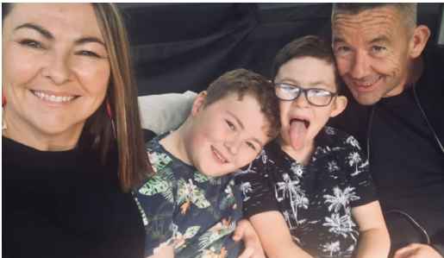

Blair Hawthorne
“I’ve always had a passion for supporting people with disability. As a kid, back in New Zealand, Dad used to get me involved in all sorts of community events. I have vivid memories of fundraising for ‘horse riding for the disabled’ by bagging and selling chicken manure (only in small town New Zealand).

More recently, I have been influenced by my neurodiverse twins, Henry and Oscar, and autistic youngest son Freddie. As a parent of an autistic little man, the statistics on the gap in employment for people with disability provide a really clear purpose: closing the gap on employment for people with disability.

My vision for NABility for the next two years is to increase representation of people with disability at NAB and that we do it in a way that drives an inclusive culture, while harnessing the collective power of our colleagues. I want NABility to share more of their stories of how we have made a real difference for our colleagues, so we know what disability inclusion looks like.”

Jodie Morrison
“10 years ago, when my son was about a month old, he was diagnosed with Velo Cardio Facial Syndrome. It was a relatively unknown syndrome, although it’s the most common after Down Syndrome (even the doctors had to Google information about it).

From the beginning we had amazing support through the Royal Children’s Hospital and Early Childhood Intervention Services. As he got older, he struggled with mainstream sports due to his conductive hearing loss and cognitive abilities. When the opportunity to volunteer at the Special Olympics came up, I jumped at the chance to understand more about the community that supports athletes with disability to thrive in sports. This was the first time I came across NABility and wanted to be involved in creating this supportive environment where colleagues with disability can thrive at NAB as well.

I’m proud to be part of NABility (and now a Co-Chair) and am excited about what we can achieve. There’s a lot to do to make sure we have a workplace where our colleagues with disability feel comfortable and confident to talk openly about what adjustments need to be made. I want to see NAB as the employer of choice for people with disability because they know it’s a workplace where they are enabled to thrive

Our Accessibility Action Plan 2023-2024

Goals | Measures for success
1. We’re actively working towards being an employer of choice for people with disability. | 1. Our recruiters and People Leaders are skilled to employ more people with disability through improved connections and learning opportunities with disability organisations  2. We’re implementing tools/technology to enable the success of colleagues with disability at work  3. NABility, our employee resource group, is actively engaging our networks and building awareness of our equitable recruitment and retention practices  4.We’ve implemented a mentoring and coaching program for colleagues with disability to improve their career development, as well as pathways to leadership for people with disability
2. We’ll help our communities prosper by supporting disability organisations and businesses to solve emerging issues | 1. We support disability organisations in our community through our expertise and NAB Neighbourhood  2. We support entrepreneurs and small business owners with disability in our community through our expertise
3. We’ll use data and insights from our customers to listen, understand and implement improved accessibility into their experience | 1. We’re working to provide improved inclusive and accessible banking services for our customers  2. We’re continuing expand our reach to disability organisations through the Accessibility Roundtables each year  3. We use relevant benchmarking tools to measure our progress to create a more accessible experience for our customers

Our Governance and Leadership

We have a strong Accessibility Action Plan governance structure in place. With specific actions under our three goals that help us continuously embed accessibility across the business.

How the structure works
The Accessibility Action Plan Steering Committee is supported by our Executive Sponsor and is responsible for the delivery of our Accessibility Action Plan. It’s made up of senior executives from across the business with oversight and assistance from Culture, Leadership and Learning.

The Associate Director Accessibility supports the development and implementation of the Accessibility Action Plan, and reports on its progress to our Executive Sponsor, Sharon Cook (Group Executive, Commercial Services).

The Accessibility Action Plan Working Group’s role is to put the plan in place, with assistance from the Digital Accessibility team and NABility (our employee resource group).

We update our customers, colleagues and community on the plan’s progress. To measure our success, we’ll benchmark this progress every two years using the Australian Network on Disability’s Access and inclusion Index.

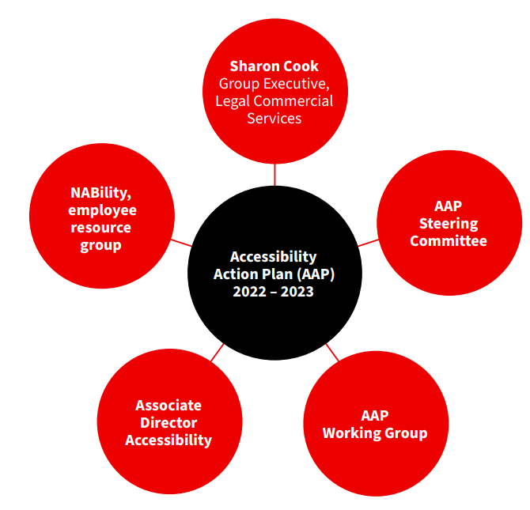

Your feedback helps
At NAB, we welcome all suggestions and feedback on our Accessibility Action Plan.
Whether you’re a customer, colleague or part of the community, please get in touch with us.
Email: accessibility@nab.com.au
Phone: 1800 152 015 and select option #2

We support customers who use the National Relay Service. If you’re Deaf, hard of hearing and/or have a speech impairment, you can contact us through this service.

Write to: National Australia Bank Head of Customer Solutions Reply Paid 2870 Melbourne Victoria, 8060

You can also speak to us in person at your local branch.

Alternative Access Formats

We’ve made our Accessibility Action Plan 2023 – 2024 available in Word and Easy Read versions at nab.com.au.
Need an alternative format email? Let us know at alternateformats@nab.com.au

